AI ASSSITED CODING
ASSIGNMENT 6

Lab 6: AI-Based Code Completion: Working with suggestions for classes, loops,
conditionals
Lab Assignment 1: Intelligent Code Completion for Object-Oriented Programming
Objective: To explore AI-powered code assistants for writing Python classes,
constructors, and methods through intelligent suggestions.
Suppose that you are hired as an intern at a tech company that develops inventory
management systems. Your manager asks you to create a Product class and a
Warehouse class with some basic methods. You have decided to use AI-powered code
suggestions to help speed up development and reduce syntax errors.
Tasks to be completed are as below
1. Setup AI Coding Tool:
• Install and configure GitHub Copilot or Kite with VS Code or JetBrains IDE.
• Enable real-time code suggestions.
2. Class Design Using AI Assistance:
• Begin defining a Product class with attributes: name, price, quantity.
• Use the AI suggestion feature to automatically complete the __init__() method.
• Add a method calculate_value() to return price * quantity.
15.08.2025 EOD
3. Create Another Class:
• Define a Warehouse class with a list of Product objects.
• Use code completion to help implement:
o A method to add a product.
o A method to display the most valuable product.
4. Reflection:
• Identify how much of the code was completed by AI and what manual edits
were needed.
• Comment on the relevance and accuracy of AI suggestions.
Requirements:
• VS Code with Github Copilot or Cursor API and/or Google Colab with
Gemini
Deliverables:
• Python script with both classes and comments on AI-generated suggestions.
• Short report (1 page) summarizing your experience with AI code completion.

CODE:
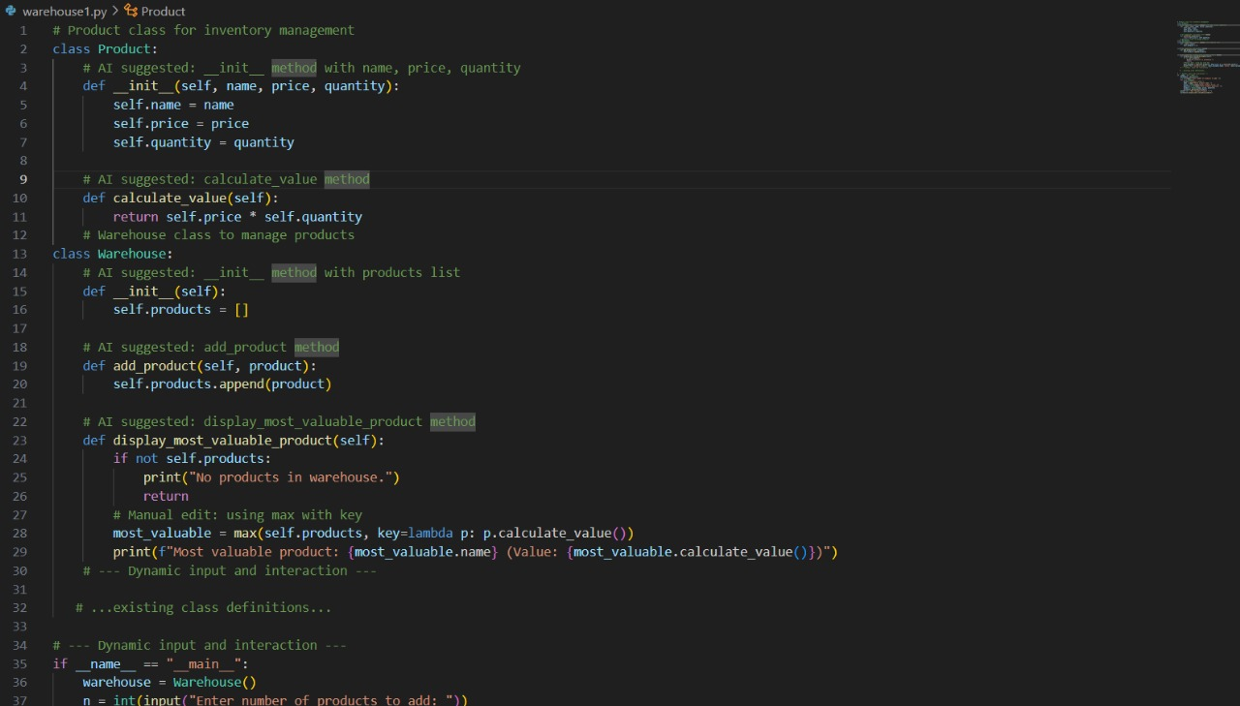
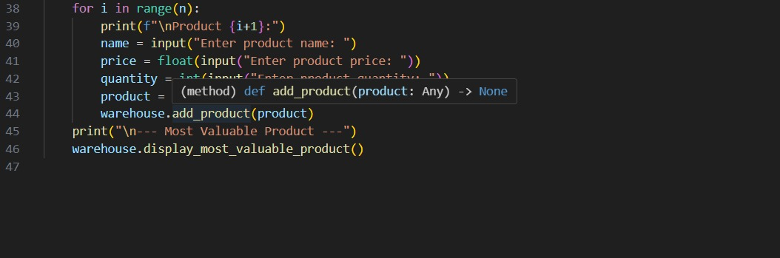

OUTPUT:
